1. Why are apple processors better and how could the rest be better?

Apple Silicon chips are RISC chips, while Intel chips are CISC chips. The comparison is not Apple vs Intel, but RISC vs CISC. “RISC” is “reduced instruction set computing,” and “CISC” is “complex instruction computing.”

**CISC** chips, such as Intel and AMD, have a large number of instructions, of varying length, and some are rarely used. The CISC chip has the overhead of determining whether it has the entire instruction. CISC chips acquire cruft over the years, which slows them down. Since the instruction set is complicated, the chip is more complex and therefore slower in comparison to an equally powerful RISC chip.

**RISC** chips, such as Apple Silicon and ARM, have fewer instructions, and all of them have the same length, so there is no overhead in determining whether the chip has the entire instruction. Since the instruction set is simple, the chip is simpler and therefore faster.

RISC chips power the fastest supercomputer in the world, which is in Japan.

<https://www.cnbc.com/2020/11/10/why-apple-is-breaking-a-15-year-partnership-with-intel-on-its-macs-.html>

1. The difference between each processor and the characteristics of them?

**Microprocessor**

It can be on-chip memory and few interfaces can be interacting to the outer world via interrupting lines, and the other can be ports and memory registers to interact with the external world. These ports are often termed as programmable and make them act as output or input. These programs can be fed and modified according to the behaviour of the devices.

**Microcontroller**

The input reading and reacting to its corresponding output is the fundamental function of the basic microcontroller and so it is called as general-purpose input and output processors (GPIO).

**Embedded Processor**

The embedded processor is structured to control the electrical and mechanical functions. It comprises of numerous blocks like timer, program memory, data memory, reset, power supply, data memory, interrupt controller, clock oscillator systems, interfacing circuits, specific circuits and system application ports and circuits.

**Digital Signal Processor**

The digital signal processor is used for filtering, measuring, compressing analogue and digital signals. The processing of signal means that manipulation and analysis of digital signals. This process can be made using application specified integration circuits, digital signal processor, field-programmable gate array or it can be a computer to achieve a distinct signal. The processors in DSP are used for barcode scanners, oscilloscope, printers, mobile phones. These processors are used for rapid and implied for real-time applications.

<https://www.youtube.com/watch?v=dcNk0urQsQM> **Microprocessor** and **microcontroller**

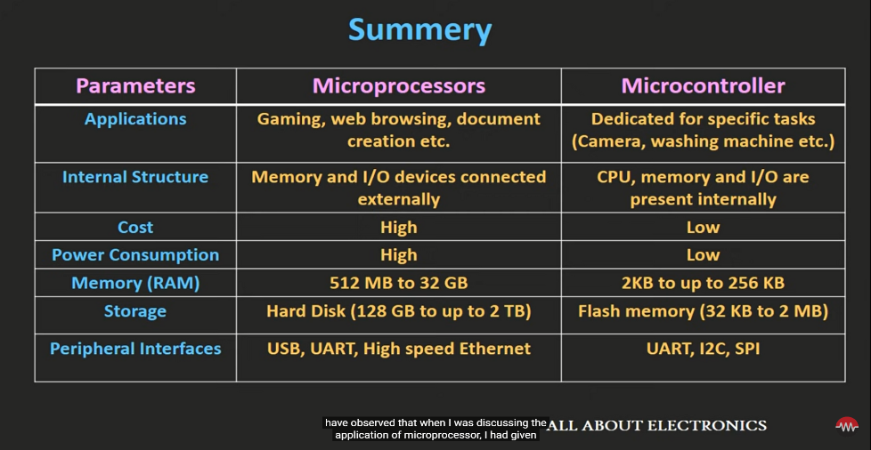

1. What is tabulation and memoization?

Tabulation: Bottom Up

Memoization: Top Down

<https://www.geeksforgeeks.org/tabulation-vs-memoization/>

<https://www.youtube.com/watch?v=PrXbn8-zw14>

<https://www.youtube.com/watch?v=4KdfomRGDAE&t=60s>

1. What is linear probing?

Handles collision by placing the colliding items in the next available table cell

Each table cell inspected is referred to as a probe

Colliding items lump together causing future collision to cause a longer sequence

1. Watch Mostafa Saad hashing video. <https://www.youtube.com/watch?v=Rp3KxUdV09Y&t=13s>

2 Methods to solve the collision

**Chaining**

Store all elements that hash to the same slot in a linked list.

Store the pointer to the head of the linked list in the hash table slot.

**Open Addressing**

All elements stored in the hash table itself.

When collision occur use a systematic (consistent) procedure to store elements in free slots of the table.

1. What is dynamic memory allocation and how to make it?

**The process of allocating memory at the time of execution is called dynamic memory allocation**

**Pointers Play An Important role in dynamic memory allocation, allocated memory can only accessed through POINTERS**

Memory allocated "on the fly" during run time

dynamically allocated space usually placed in a program segment known as the heap or the free store

Exact amount of space or number of items does not have to be known by the compiler in advance.

For dynamic memory allocation, pointers are crucial

We can dynamically allocate storage space while the program is running, but we cannot create new variable names "on the fly"

For this reason, dynamic allocation requires two steps:

Creating the dynamic space.

Storing its address in a pointer (so that the space can be accessed)

To dynamically allocate memory in C++, we use the new operator.

**Built In functions : malloc(),calloc(), realloc(), free().**

<https://www.youtube.com/watch?v=udfbq4M2Kfc>

1. All c++ frameworks in all tracks.

<https://github.com/fffaraz/awesome-cpp>

<https://github.com/fffaraz/awesome-cpp#frameworks>

1. What is web services, micro-services and APIs?

API

Application Programming interface

Can use for any application programing interface

It is a software interface that allows two applications to interact with each other without any user intervention.

APIs provides product or service to communicate with other products and services without having to know how they’re implemented.

Web services

Software available for others to use over the web.

Part of API

Using XML and Jason

Can be Rest OR Soap

A Web service is a collection of open protocols and standards which are widely used for exchanging data between systems or applications.

Software applications are written using various programming languages and running on multiple platforms. It allows you to use web services to exchange data over computer networks.

Microservices

also known as the microservice architecture - is an architectural style that structures an application as a collection of services that are

Highly maintainable and testable

Loosely coupled

Independently deployable

Organized around business capabilities

Owned by a small team

The microservice architecture enables the rapid, frequent and reliable delivery of large, complex applications. It also enables an organization to evolve its technology stack.

<https://www.quora.com/What-is-the-difference-between-an-API-a-web-service-and-a-microservice>

<https://www.youtube.com/watch?v=hNauahXZpZ4>

1. how to write a multiple line code with different programming languages in the same program?

File

Embedding

Linking

Polyglots

1. All about cronjobs with examples

A cronjob is a Linux command used for scheduling tasks to be executed sometime in the future. This is normally used to schedule a job that is executed periodically

**– for example,** to send out a notice every morning. Some scripts, such as Drupal and WHMCS may require you to set up cronjobs to perform certain functions.

1. comparison between core i9 and i11 in the performance of the same task
2. Why set is the fastest data structure?

Sets are implemented using hash tables. Whenever you add an object to a set, the position within the memory of the set object is determined using the hash of the object to be added. When testing for membership, all that needs to be done is basically to look if the object is at the position determined by its hash, so the speed of this operation does not depend on the size of the set. For lists, in contrast, the whole list needs to be searched, which will become slower as the list grows.

This is also the reason that sets do not preserve the order of the objects you add.

Note that sets aren't faster than lists in general -- membership test is faster for sets, and so is

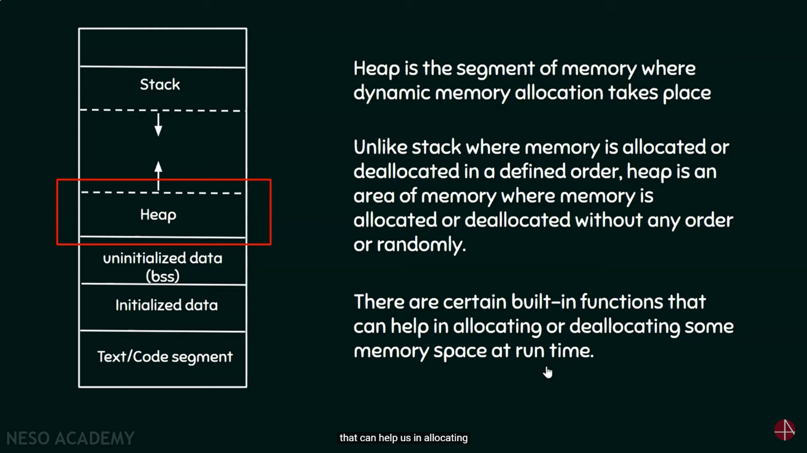 removing an element. As long as you don't need these operations, lists are often faster.